38th Annual Tulip Pedal Bike Ride
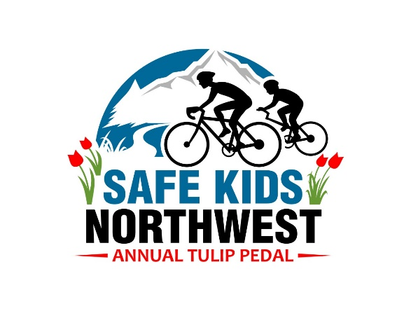
April 20st, 2019

Last Name
First Name
Address
Telephone
Email
Waiver and Release from Liability
In consideration of the acceptance of my application for entry in the Tulip Pedal, I hereby waive, release and discharge all claims for damages for death, personal injury or property damage which I may have, or which may hereafter accrue to me, as a result to my participating in the Tulip Pedal. This release is intended to discharge in advance the promoters, the sponsors, the promoting clubs, the officials, Safe Kids Northwest, North Region EMS & TCC, Skagit Valley Tulip Festival and invoiced municipalities or other public entities (and their respective agents and employees), from and against any and all liability arising out of or connecting in any way with my participation in the Tulip Pedal, even though that liability may arise out of negligence or carelessness on the part of the persons or entities mentioned above. It is understood and agreed that this waiver, release and assumption or risk is binding on my heirs and assigns. I understand ANSI or Snell approved bicycle helmet is required for this event.

Signature Date

Size of Shirt (Check One) |  |  | For Official Office Use Only
Children Medium |  |  | Amount Paid
Children Large |  |  | Transaction  (Circle One) | CASH | CHECK | CC
Men’s Small
Men’s Medium |  |  | Credit Card Number
Men’s Large
Men’s X-Large |  |  | Expiration Date
Men’s XX-Large
Women’s Small |  |  | CVV
Women’s Medium |  |  | Processed By ______________(Office Signature)
Women’s Large
Women’s X-Large

